2022 Education Excellence Forum  (Portland/Vancouver Metropolitan area Ethiopian Diaspora community) | 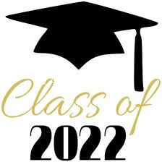  “It takes a village to raise a child”
‘’Education is the most powerful weapon which you can use to change the world”-  Nelson Mandela  This forum is intended to bring the diaspora community together to create awareness how we can raise a vibrant and responsible 2nd generation in this land of opportunities.  Professionals and professors from the WA & OR area are great resources and initiating a network could positively impact the lives and education of the young generation in a meaningful and sustained ways. | ‘’Train up a child in the way he should go, and when he is old he will not depart from it’’. Proverbs 22:6  “My people perish for lack of knowledge “ Hosea 4:6

Event details:
All high school students , their parents and siblings , community leaders, diaspora community members who have the heart to make a difference in our children lives are encouraged to attend.
1. Forum : How the diaspora community can take the full advantage of the education opportunities in USA. Challenges/opportunities and how we can mobilize resources to positively influence the lives/ education of the 2nd generation and empower families.
2. Recognize the 2022 high school & college gradates
3. Recognize some exemplary individuals and families in the community.
4.When: Saturday July 23rd , 2022, 1pm -3pm
5. Where: 3515 NE Killingsworth St , Portland OR 97211
6. Any questions? Please call or text Worku Negussie @ (360) 735 0204

